PATHSHALA NEPAL FOUNDATION

PRE-UNI PROGRAM

Baneshwor, Kathmandu

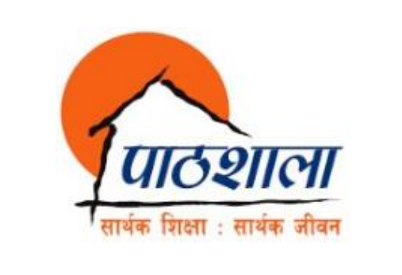

Lab Assessment Report on

Database Management System (Part A)

**Submitted By:** **Submitted To**

Name: Raunak Raj Adhikari Department of Computer Science

Class: 12 PATHSHALA NEPAL FOUNDATION

Group: 1

Date: 2023-08-13

2. Introduction to DBMS with its objectives, features and advantages as well as with examples.

3. Define Term Data, Information, Database, Field, Record, Query, Candidate Key, Primary Key, and Foreign Key.

4. Introduction to SQL.

5. Define the DDL, DML, DCL, composite key, alternate key, and super key.

6. Differentiate between DBMS and RDBMS.

|  |  |  |
| --- | --- | --- |
| **S.N** | **DBMS** | **RDBMS** |
| 1. |  |  |
| 2. |  |  |
| 3. |  |  |
| 4. |  |  |
| Ex: |  |  |

7. Perform the following task:

* Create a database named **school**.



* Create a table named **stud_info** in the above-mentioned database with the following details.

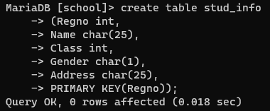 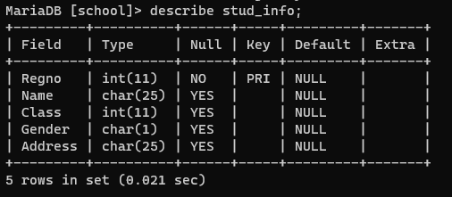

* Add the following records in the table **stud_info**.

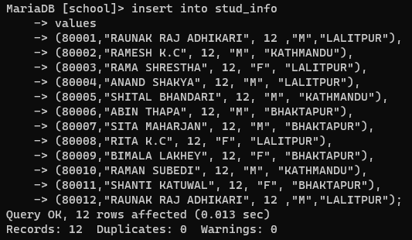 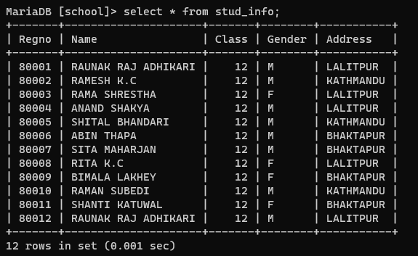

* Display all the record of students who are from LALITPUR district.

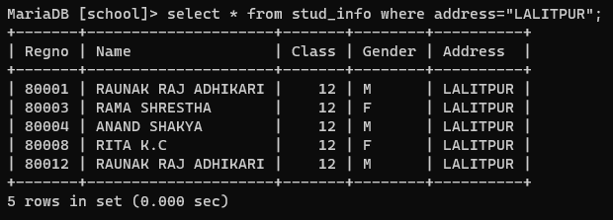

* List all the details of only girls.

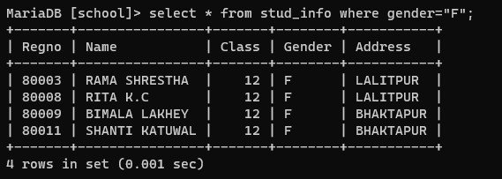

* List all the MALE students from Kathmandu.

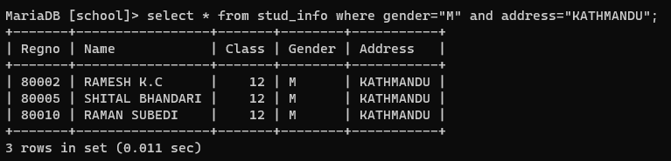

* Display all the student’s information who are either from Bhaktapur or Lalitpur

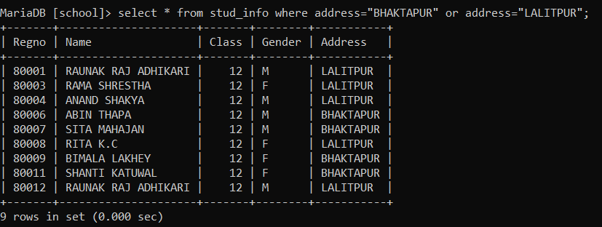

* Display all the students whose name started with the character R.

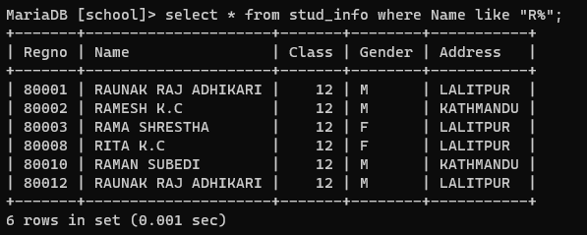

* Display all the information of students whose name ended with the letter A.

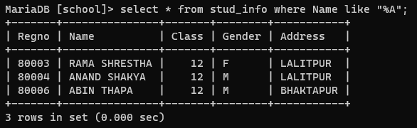

* List all the records having registration number between 80004 and 80008.

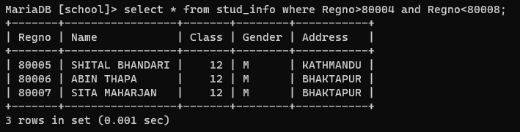

* List all the records in alphabetic order to the name of students.

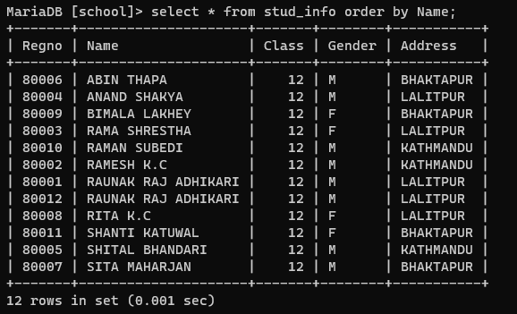

* Add an attribute named dob (date of birth) as date (yy-mm-dd) in the table **stud_info**.

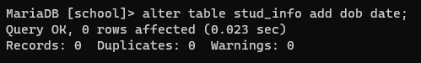

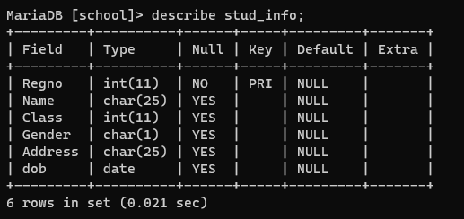

* Set the validity of Regno as the value should be more than 80000.

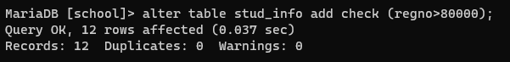

* Update the dob of the following students as follows:

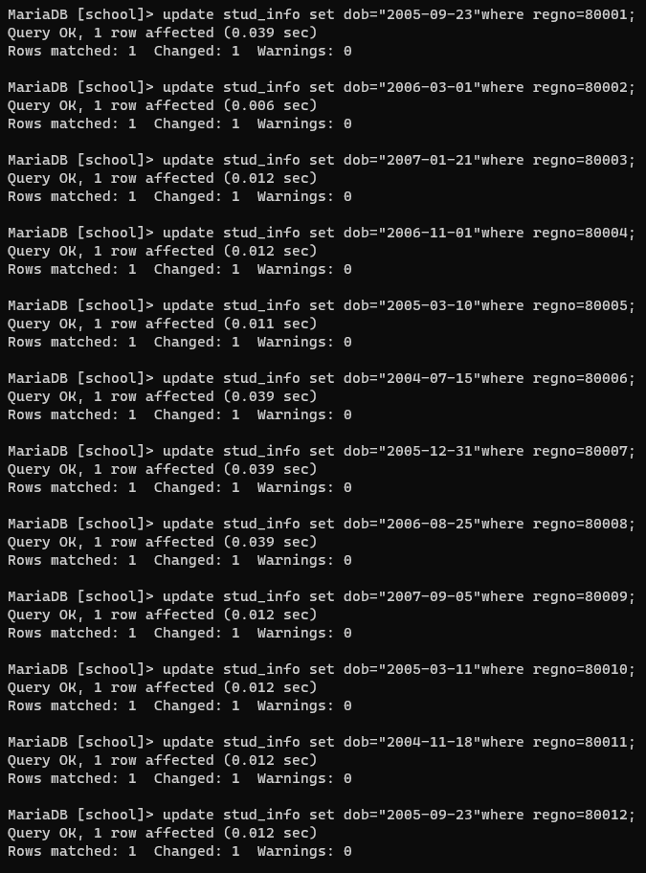

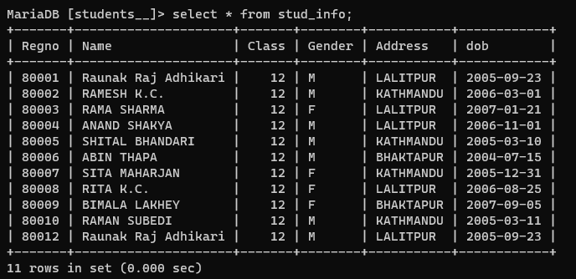

* List all the students who were born in the year 2005.

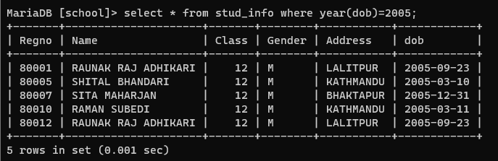

* List all the students who were born in the month march of 2006.

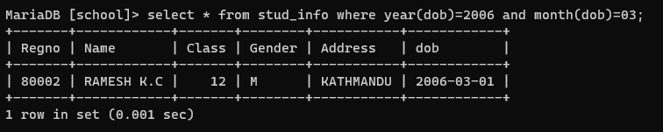

* Display Regno, Name and Age of all the students.

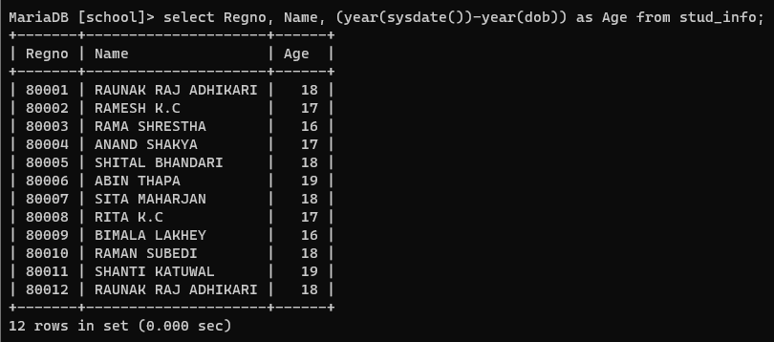

* Change the dob of SITA MAHARJAN whose Regno is 80007 to “2005-10-25”.

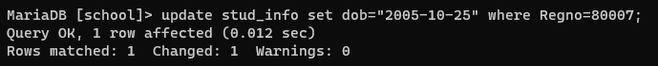

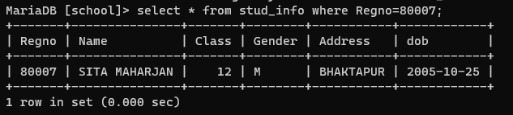

* Display all the students who are 18 years or below.

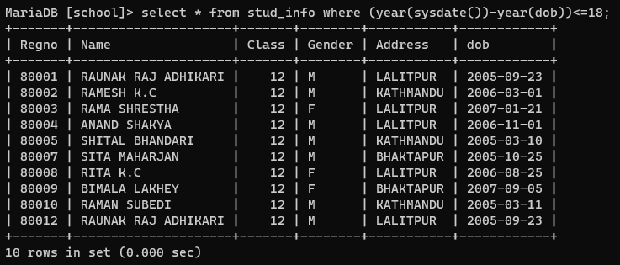

* Display all the students who are from KATHMANDU and born in the year 2005.

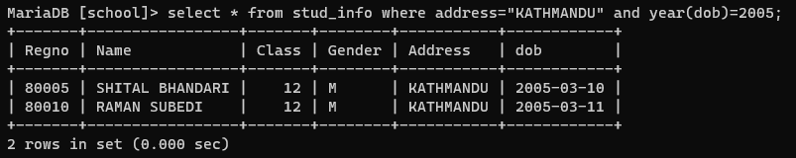

* Display all the students whose name is having second letter as “A”.
* 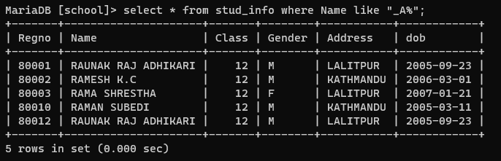
* Display all the female (girl) students who were born in the year 2007.

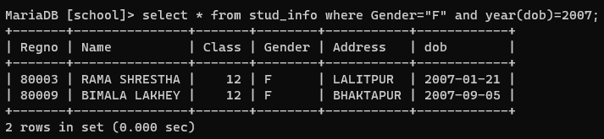

* Display all the made (boy) students who are 18 years or older.

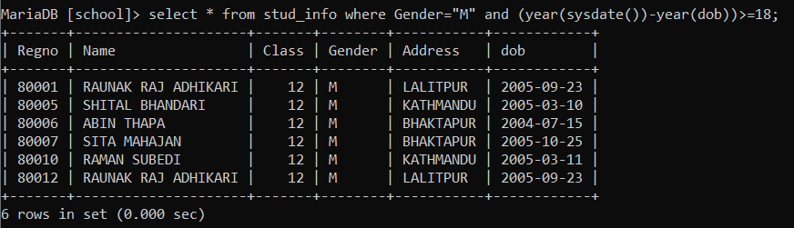

* Delete the record having regno 80012.



